Insert Org Name

2018 NCSR Data Reporting Template

Background (possible discussion items)
- Provide background on current security program
- Include recent milestones & security program successes
- Discuss where you have been and where we are heading
- Discuss planned/milestones goals
- Discuss number of years participated in NCSR

Previous Year’s Accomplishments (possible discussion items)
- List acknowledgments/accomplishments
- New Hires
- List new implementations
- Updates
- Participated in

Assessing INSERT ORG NAME Security Posture
This past year INSERT ORG NAME participated in MS-ISAC’s Nationwide Cybersecurity Review (NCSR).
The Nationwide Cybersecurity Review (NCSR) is a free, confidential, annual self-assessment survey that is based on the National Institute of Standards and Technology (NIST) Cybersecurity Framework (CSF). It is sponsored by the Department of Homeland Security (DHS) and the Multi-State Information Sharing & Analysis Center (MS-ISAC).
The NCSR evaluates cybersecurity maturity across the nation while providing actionable feedback and metrics directly to individual respondents in State, Local, Tribal & Territorial (SLTT) governments.
Using the results of the NCSR, DHS delivers a biennial anonymous summary report to Congress providing a broad picture of the cybersecurity maturity across the SLTT community.
The NCSR is a valuable tool, it allows us to receive metrics specific to our organizations, develop a benchmark to gauge our year-to-year progress, and anonymously measure our results against our peers. It also provides a way to map our security strategies to the controls specified by NIST 800-53, COBIT & CIS Controls.

NCSR Structure
The NCSR question set was built upon the NIST CSF with some minor alterations. The questions set consists of a collection of cybersecurity-related activities organized into five main functions: Identify, Protect, Detect, Respond, and Recover. These five main functions are broken down into 108 sub-categories which the NCSR uses as a basis for the questions in the NCSR self-assessment.

Overview of the NIST CSF Functions:
Identify Function: The activities under this functional area are key for an organization’s understanding of their current internal culture, infrastructure, and risk tolerance. By incorporating sound risk management principles into cybersecurity programs, organizations will be able to continuously align their efforts towards protecting their most valuable assets against the most relevant risks.
Protect Function: The activities under the Protect Function pertain to different methods and activities that reduce the likelihood of cybersecurity events from happening and ensure that the appropriate controls are in place to deliver critical services. These controls are focused on preventing cybersecurity events from occurring.
Detect Function: The activities under the Detect Function pertain to an organization’s ability to identify incidents.
Respond Function: The activities within the Respond Function examine how an organization plans, analyzes, communicates, mitigates, and improves its response capabilities.
Recover Function: The activities within the Recover Function pertain to an organization’s ability to return to its baseline after an incident has occurred. Such controls are focused not only on activities to recover from the incident, but also on many of the components dedicated to managing response plans throughout their lifecycle.

NCSR Maturity Scale
The NCSR utilizes a maturity scale that assesses how an organization is addressing the different activities within the NIST CSF. The maturity scale allows participants to indicate how formalized these cybersecurity activities are within their organization. Following risk management principles, the response framework includes allowing organizations to identify which activities they have formally acknowledged and chosen not to implement because of their own risk assessment.
In order to provide a target for the SLTT community, a team of SLTT cybersecurity professionals developed a recommended minimum maturity level as a common baseline for the NCSR. The maturity level uses Implementation in Process as the recommended minimum maturity level. The below figure provides a full breakdown of the NCSR Maturity Level response scale along with the scores associated with each maturity level.
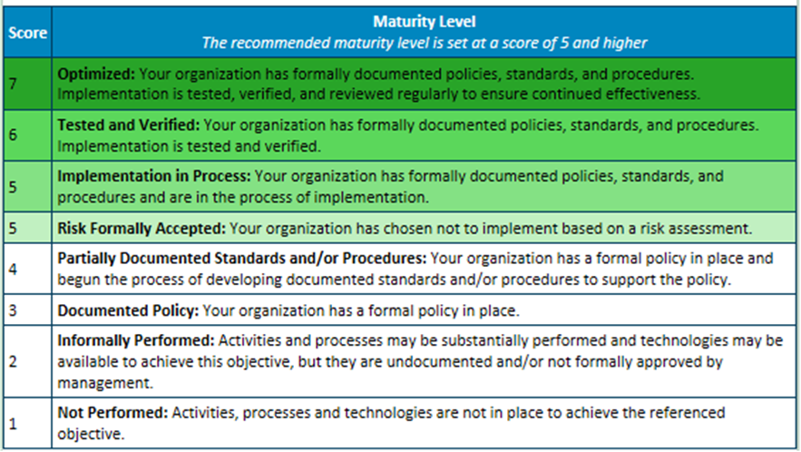

Where Are We Today?
Insert report titled: “Current NCSR Results” Provides your organizations current years NCSR results across the NIST Cybersecurity Functions and Categories.
Possible Discussion Items:
- Call out strengths
- Call out areas for improvement
- Create a baseline/road map based on these results

Where Have We Progressed?
Insert report titled: “Year-to-Year Results” Provides your year-to-year NCSR results across the NIST Cybersecurity Functions and Categories.
Possible Discussion Items:
- Drill down to different categories to see where you increased/decreased
- To what do you attribute your scores increasing/decreasing (what can you tie to this data to?)
- What road blocks are you seeing?

How Do We Compare Against Our Peers?
Insert report titled: “Year-To-Year Peer Profiles” Provides your year-to-year NCSR results across the NIST Cybersecurity Functions and Categories in comparison to your peers.
Possible Discussion Items:
- Explain why above and/or below your peers
- Possibly discuss different ways maturity is being measured
- Are there relative factors that differentiate you from your peers?

HIPAA Compliance
If applicable, attach report titled: “Year-to-Year Compliance Reports” which is a unique report that maps the HIPAA Security Rule to the NIST CSF and ties in your NCSR responses.
Possible Discussion Items:
- The intent of this report is to use it as a tool for a self-assessment of your HIPAA Security Rule compliance. The report assists in developing a gap assessment and identifying areas of improvement
- Serves as a valuable documentation trail

NCSR Findings
Provides a report that maps your organization’s NCSR questions that were answered below the recommended minimum maturity of “Implementation in Process”, to the NIST Cybersecurity Framework informative references (NIST CSF 800-53, COBIT, and CIS Controls). The specific report/dashboard in the NCSR portal is named “2018 Findings”.
Possible Discussion Items:
- Provides a recap of the questions answered below the recommended minimum maturity of implementation in process
- Provides references to standards you may be utilizing outside of the CSF
- Identifies the controls needed to implement and/or remediate the finding
- Utilize the report as a tool to develop a roadmap for improvement

Attach 2017 Nationwide Cybersecurity Review Summary Report

Click Here

