January 2017
Volume 12, Issue 1

Cyber Tips for Holiday Shopping

Insert your logo here | Insert your agency name and contact info here

From the Desk of Thomas F. Duffy, Chair, MS-ISAC
We wish you, your colleagues, and your families a happy and prosperous new year! As we look back on the past year’s challenges, we also look ahead to which cybersecurity challenges will hold prominence in 2017. CIS posted a Twitter poll asking respondents to choose which of the four listed threat areas would be the biggest cyber threat in 2017. The Internet of Things (IoT) took the top spot as biggest threat by a large margin. This shouldn’t be a surprise given some of the prominent cyber attacks of 2016, including one which temporarily stopped some users from accessing popular websites such as Twitter, Spotify, and Amazon, were bolstered by compromised IoT devices.

Here are some quick primers on why these are threats to everyday users, and how you can work to protect yourself out there in the connected world.

Internet of Things (IoT)
Our top polling threat, the Internet of Things, is comprised of everyday objects and household items that are connected to the Internet. Examples include smart TVs, routers, smart thermostats, and smart home devices, among many others. Although convenient, these devices often come out of the box with very few security features, little to no security support, and often remain in use with default passwords in users’ homes. As a result, these compromised devices can be used to attack others, slowing your Internet access and possibly preventing access to popular sites like Twitter, Amazon, Spotify, etc. When purchasing and using IoT or connected home devices, be sure to change the default passwords that come pre-loaded on the device to strong and unique ones of your choosing, and also keep up-to-date on patches and updates as they become available. Basic recommendations for creating a strong password are to use at least 10 characters including uppercase and lowercase letters, numbers, and symbols. Further information on setting a strong password is available in the guide linked at the end of this newsletter.

Data Dump Re-use
With the number of high profile data breaches over the past year at well-known organizations, this will continue to be an important area of concern moving forward. Cyber criminals sell or publicly post stolen usernames, passwords, social security numbers, and other personal information. Unfortunately, many people tend to re-use the same login credentials between many of their accounts due to the difficulty of remembering multiple passwords. This can allow cyber criminals to take their stolen credentials and attempt using them to access their other online banking, shopping, and other accounts.
APT
Advanced Persistent Threat (APT) refers to cyber threat actors operating for or on behalf of nation-state governments like Russia and China, who are looking to compromise, steal, change, or destroy information for the purposes of espionage, disruption, or destruction. State and local governments, critical infrastructure, universities, and the employees of all of these entities are targeted by this threat. Users can reduce the risk from this type of threat actor by using strong and unique passwords, regularly patching their computers and devices, and thinking twice before opening suspicious emails/attachments or clicking links.
Ransomware
Ransomware is a form of malware that aims to block a user from having access to their own systems, commonly by encrypting the infected computer’s files against the owner’s will. Once access is blocked, the ransomware then requests money (a ransom) in order to restore access. Cyber criminals are commonly spreading this particular malware through malicious email attachments. This highly prevalent form of malware can be mitigated by keeping your systems and anti-virus software patched and up to date with the most recent versions. Additionally, be wary of suspicious emails and do not open attachments or click on links from untrusted sources.

Consider some of the cyber threats out there as you go forward into 2017, and consider these tips for protecting you and your devices. Have a safe and happy new year, both on and off-line!

Provided By:
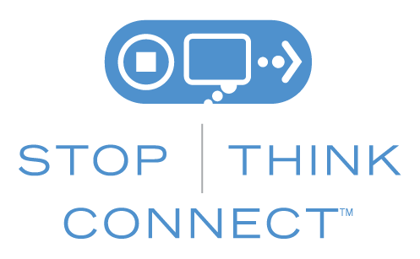

The information provided in the Monthly Security Tips Newsletter is intended to increase the security awareness of an organization's end users and to help them behave in a more secure manner within their work environment. While some of the tips may relate to maintaining a home computer, the increased awareness is intended to help improve the organization's overall cyber security posture. This is especially critical if employees access their work network from their home computer. Organizations have permission and are encouraged to brand and redistribute this newsletter in whole for educational, non-commercial purposes.
Disclaimer: These links are provided because they have information that may be useful. The Center for Internet Security (CIS) does not warrant the accuracy of any information contained in the links and neither endorses nor intends to promote the advertising of the resources listed herein. The opinions and statements contained in such resources are those of the author(s) and do not necessarily represent the opinions of CIS.

