Monthly Cybersecurity Tips Newsletter
VOLUME 17, ISSUE 5 • 2022

Winning Posters for 2022
From the desk of Karen Sorady
VICE PRESIDENT, MS-ISAC MEMBER ENGAGEMENT
We at the MS-ISAC are overjoyed to announce this year’s winning Kids Safe Online poster designs! Each October during Cyber Security Awareness Month, K-12 students across the country focus their creative genius on inventing artwork that teaches us about internet safety and security. As with past years, we received many wonderful pieces, and of those, 13 will grace the pages of our next Kids Safe Online Activity Book. MS-ISAC members nationwide use our posters to spread cybersecurity awareness and inform their employees about cyber threats.
A Look at the Winning Posters
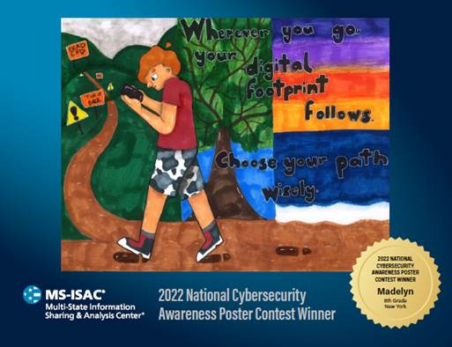
“Wherever you go, your digital footprint follows.” — Madelyn, 8th Grade, New York
Madelyn, an 8th grader from New York, created this stunning design that reminds us to watch our digital footprint. Every text we send, every message we keep, and every file we download can carry dangers with it if we’re not careful. Sometimes, it takes a child to remind us that once we click “send,” it’s too late. In the digital world, it’s impossible to take things back, and any post we make could be misused.
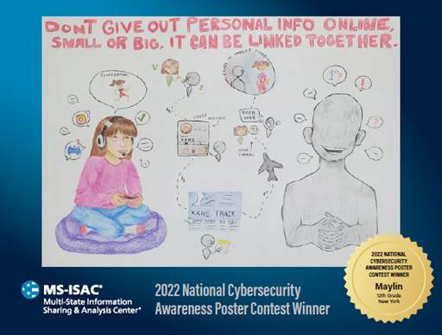
“Don’t Give Out Personal Info Online” — Maylin, 12th Grade, New York
Maylin, a 12th grader, submitted an amazing piece of art meant to teach us a lesson about leaving our personal information exposed online. Even details that might seem inconsequential by themselves could be pieced together by a malicious actor. For this reason, it’s important to lock down our social media accounts with smart privacy settings and keep a close eye on what we allow the whole world to see.
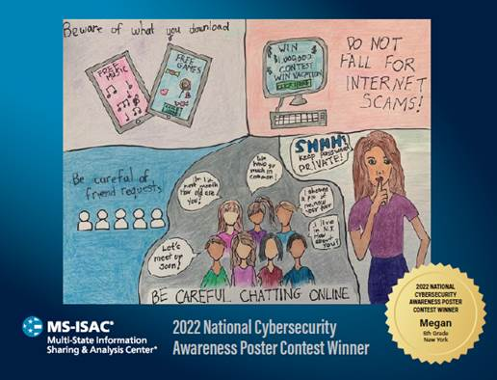
“Do Not Fall for Internet Scams” — Megan, 9th Grade, New York
Megan, a student in 9th grade, provided useful info in an entertaining format. Takeaways include avoiding malware disguised as games or music and dodging internet scams. The adage that “if it sounds too good to be true, it probably is” applies in the virtual world. When we accept a friend request or chat with someone online, we let them into our circle of trust, and that can be a risky proposition.
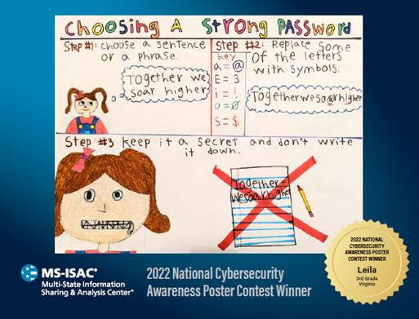
“Choosing a Strong Password” — Leila, 3rd Grade, Virginia
Our last winning poster design comes from Leila, a 3rd grader in Virginia, with three steps to better password security. While we all hope for a beautiful, password-less future, in the present, they still constitute the keys to our various kingdoms. Along with other tips, Leila tells us to choose passphrases – something longer than just a single word – which is good advice to help us ward off brute-force attacks.

Cybersecurity as a Life Skill

Today’s kids have grown up with amazing tech that, if used responsibly, can greatly enhance their lives. No other generation has had so much information at their fingertips just a click away. Of course, there are tradeoffs in an always-connected reality. That’s why cybersecurity is not just a career field but also a life skill. The good news is that there are plenty of opportunities for students interested in learning about security, including great summer options, so these white hats-in-training can practice their art year-round.
Resources for K-12 Cybersecurity Learners:
- Air Force Association’s CyberPatriot
- CyberStart America
- NIST List of K-12 Cybersecurity Competitions
- NSA/NSF GenCyber
- R00tz Asylum
- UTSA’s Culture of Cyber Security: Kids Activities

The information provided in the MS-ISAC Monthly Cybersecurity Tips Newsletter is intended to increase the security awareness of an organization's end-users and to help them behave in a more secure manner within their work environment. While some of the tips may relate to maintaining a home computer, the increased awareness is intended to help improve the organization's overall cybersecurity posture. This is especially critical if employees access their work network from their home computer. Organizations have permission and are encouraged to brand and redistribute this newsletter in whole for educational, non-commercial purposes.
Disclaimer: These links are provided because they have information that may be useful. The Center for Internet Security (CIS) does not warrant the accuracy of any information contained in the links and neither endorses nor intends to promote the advertising of the resources listed herein. The opinions and statements contained in such resources are those of the author(s) and do not necessarily represent the opinions of CIS.

